**EXPERIMENT 12**

**IP LAB**

OUTPUT:

1. ARITHMATIC OPERATIONS:

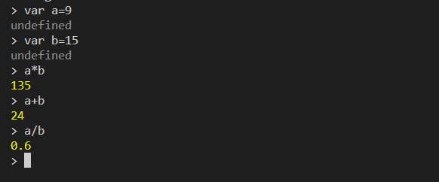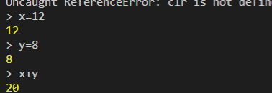

1. LOGICAL OPERATORS:

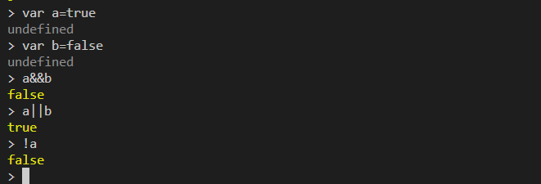

1. STORING THE VALUE OF THE VARIABLE:

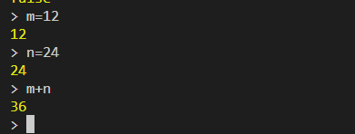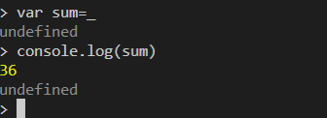

1. PRINTING TABLE USING FOR LOOP:

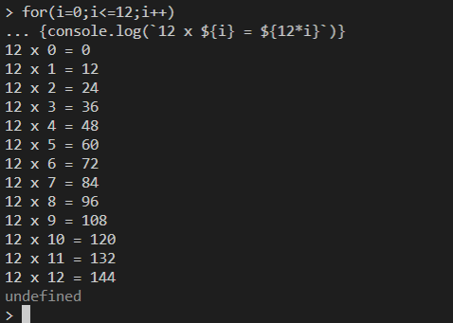

1. USING IF ELSE LOOP:

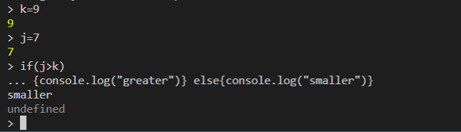

1. OPENING EDITOR MODE:

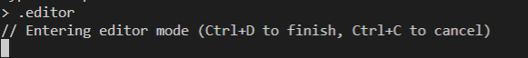

1. PRINTING FIBONACCI SERIES:

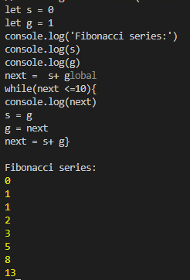

1. PRINTING PATERN:

